­­­­­

# Math

October

# ELA/Reading

# Reminders

banner with apples and crayons

### Pleasant Hill School

Peoria, Il

12/12/16

Mrs. Spradling’s 2nd Grade

We are reading a few different reindeer stories. We will be writing about reindeer facts we have learned for our non-fiction piece. We are also working on compound sentences.

This week in math we are starting continuing regrouping in 2-3 digit addition. When our ones column adds up to 10 or more we need to send the tens to the neighbor. Ten or more- send one next door!

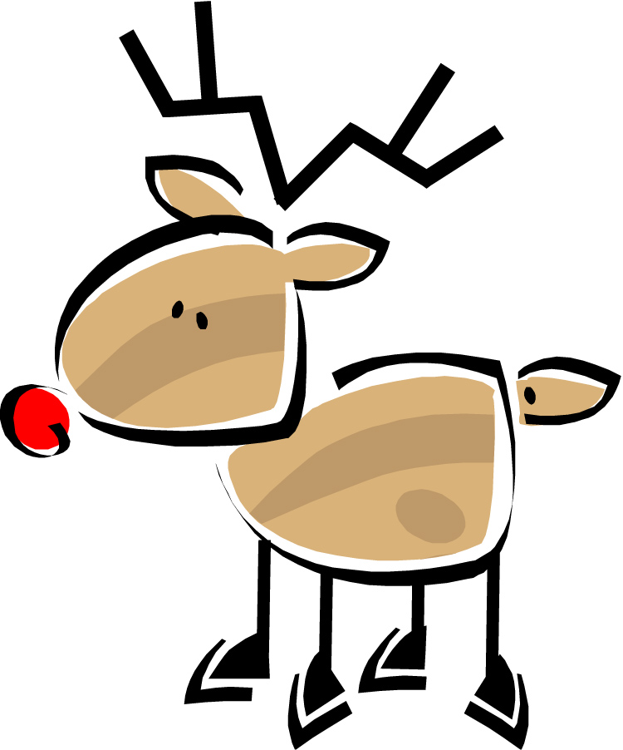

# Science/Social Studies

This week we are going to continue learning about Christmas traditions around the world.