­­­­­

# Math

October

# ELA/Reading

# Reminders

SIP Day Friday- early dismissal at 11:30

banner with apples and crayons

### Pleasant Hill School

Peoria, Il

1/30/17

Mrs. Spradling’s 2nd Grade

We are working with root words and beginning prefixes such as RE, PRE, DIS, and UN.

We are writing about groundhog facts and an opinion piece on who would be a great replacement groundhog and why.

This week in math we are continuing work on regrouping in 3 digit subtraction. We start by circling the biggest number in the ones. If there is more on the floor we borrow from next door. More on top no need to stop. Numbers the same zero is the game. This is allowing us to practice what we know about place value and borrowing ten so that we can subtract larger numbers in the ones column for subtraction.

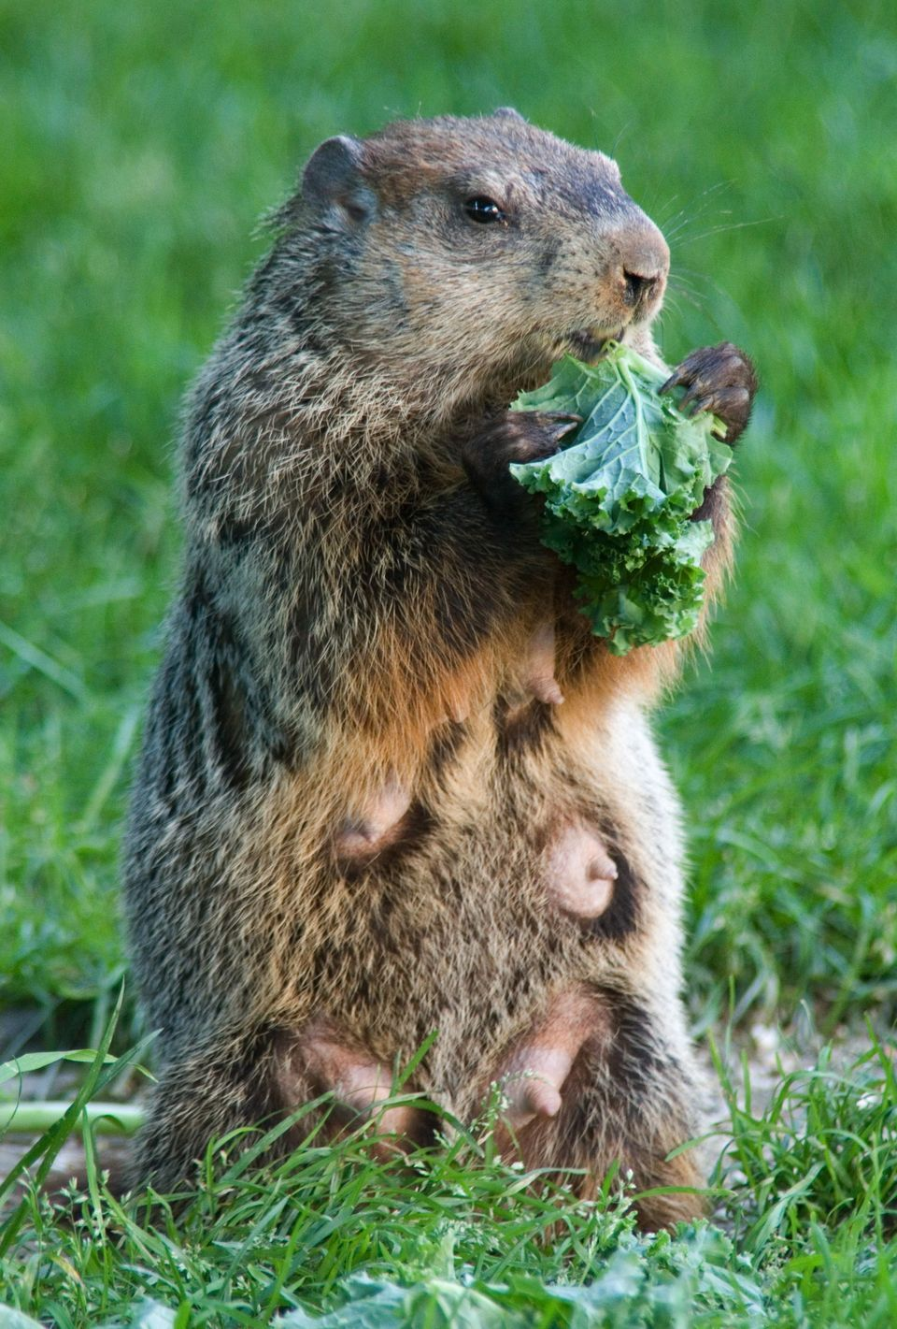

# Science/Social Studies

This week we are learning about the groundhog and other animals that dig and hibernate. We are also learning about Washington and Lincoln.