­­­­­

# Math

October

# ELA/Reading

banner with apples and crayons

### Pleasant Hill School

Peoria, Il

2/20/17

Mrs. Spradling’s 2nd Grade

We are going to be reading a few different versions of the Three Little Pigs and the Big Bad Wolf. We will compare and contrast the stories and continue working on opinion writing inspired by the stories.

This week in math we are starting work with measurement by the inch. We will practice using rulers and measuring objects around the room and identifying items around the room by their length or height.

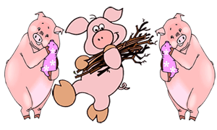

# Reminders

No School Monday

This week we will be taking part in a few different STEM activities based on the Three Little Pigs. We will build houses out of straw, sticks, bricks (Legos) and cards.

# Science/Social Studies