­­­­­

# Math

October

# ELA/Reading

banner with apples and crayons

### Pleasant Hill School

Peoria, Il

1/30/17

Mrs. Spradling’s 2nd Grade

We are going to continue working with root words and beginning prefixes such as RE, PRE, DIS, and UN. We will also be starting endings such as –ful, -ing, -ed, and etc.

We are working on opinion pieces this week. We are getting more in depth with our organization of the writing.

This week in math we are starting to work with money. We will be adding up money and learning how to identify the coins. We will only be working with quarters, dimes, nickels and pennies. A great way to get your students familiar with the coins is to pull out any loose change and play around with them!

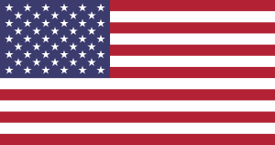

# Reminders

Turn in conference forms by Wednesday for 5 Panther Paws and Friday for 2 Panther Paws!

Valentine’s Day is next week. See notice in folders

This week we are learning about American symbols. The Statue of Liberty, Bald Eagles, the American Flag, Washington Monument, U.S. Capitol, Liberty Bell and the motto “In God We Trust.”

# Science/Social Studies